Please read the rules in the attached word file before coming to this.

In this code, the board is represented as a list of dictionaries.Four Players(Yellow,Green,Red,Blue) play the game.

The main board consists of the 52 squares( including four shaded squares on which a token can't be killed/taken out) without the particular home rows of the each player. This mainboard is the a list of dictionary made from CSVs(attached). A single dictionary has a column position( from 0 to 51), Occupants ( which shows the list of the occupants-which are basically objects of the tokens), x and y co-ordinates ( which we had calculated according to the canvas size..to be used to rect function in processing) , r, g and b(these 3 columns helps would help us to color the box/rectangle during the GUI phase. The width and length to be entered in rect function were constant(40) so did not need to be added in the CSVs.

Please see the CSVs for clarity (attached in the main folder)

Just like mainboard, 4 other boards were made: yellow_home_board, green_home_board ,red_home_board, blue_home_board. The differences between main board and these boards are this: the position starts from 0 to 12. One of the keys in the dictionary is HomeOccupants instead of Occupants( this fact is used afterwards in the code to different the board..and yet use the same name of position to achieve some functionality).

Each of these baords can only be entered by the token of same colour. See the below Picture 1:

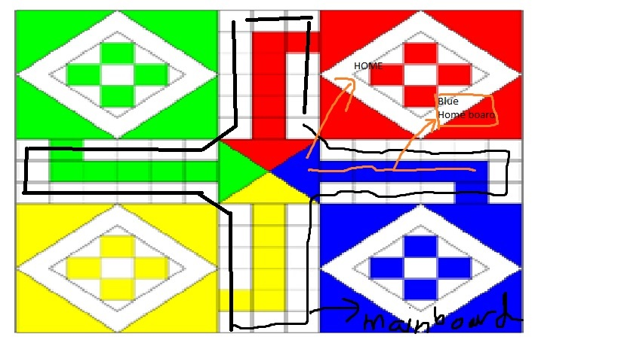See Picture 1 for clarity.

Since the Occupants list contain objects, we have created functions to print the name attributes of the objects in order to locate the objects.

These were the basic ideas that are being used. The rest of the code is documented with comments and so should not be very difficult to follow.

I have attached Picture 1 and Picture 2 in the main folder( which should be used to understand the code properly).